**Part 2: Design Alternatives**

**Project Description**

StudyBuddy is an app designed to facilitate collaborative learning among students. It connects users with peers who are studying the same subjects or courses, enabling them to form study groups, share notes, and participate in joint study sessions. The app includes features like a virtual whiteboard for collaborative problem-solving, a scheduling tool to arrange study sessions, and a chat function for real-time communication. Additionally, StudyBuddy offers resources such as flashcards, and quizzes.

**Requirements Summary**

Key requirements include user registration and profile management, the ability to create and join study groups based on subjects or courses, real-time communication tools such as chat and virtual whiteboards for problem-solving sessions, shared document and resource capabilities within groups, scheduling tools for organizing study sessions, access to educational resources like flashcards and quizzes.

**Design Space**

**What requirements may be difficult to realize?**

Access to educational resources may be the hardest requirement to realize as students have various needs when it comes to educational resources, and there is no one size fits all approach.

**What are some tradeoffs that you should or did explore?**

We originally explored having the app be for all schools in the city, but decided that would be out of our scope.

**Which tasks will be easiest to support? Which are the hardest?**

The easiest tasks to support will be the group joining feature as well as the real-time communication. The researches believe that

**Design Summary**

**Designs**

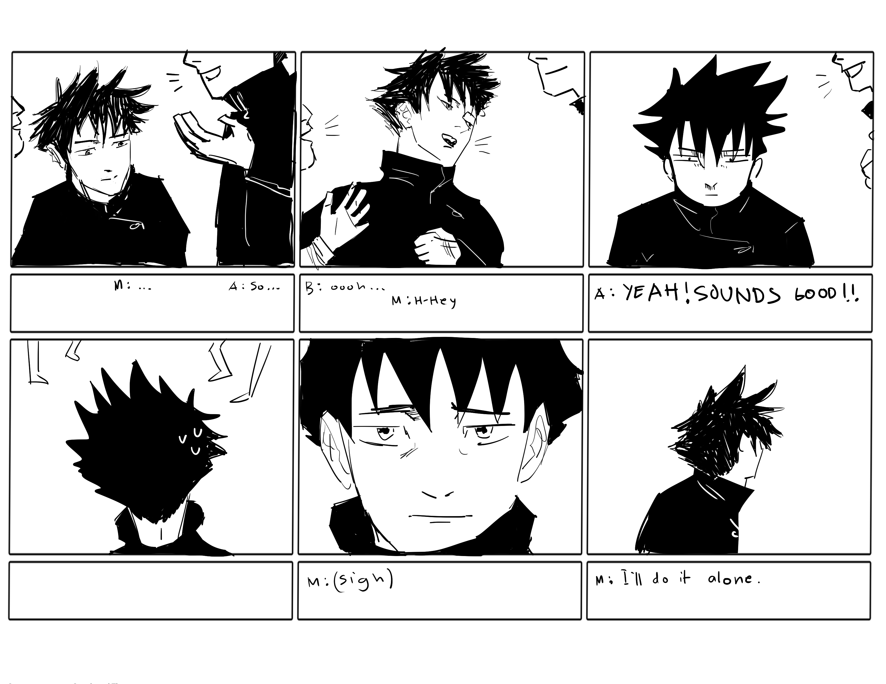

Scenario 1: Megumi is an introverted person and can't bring themself to speak to their classmates to find a group, and eventually opts to just make their group project alone

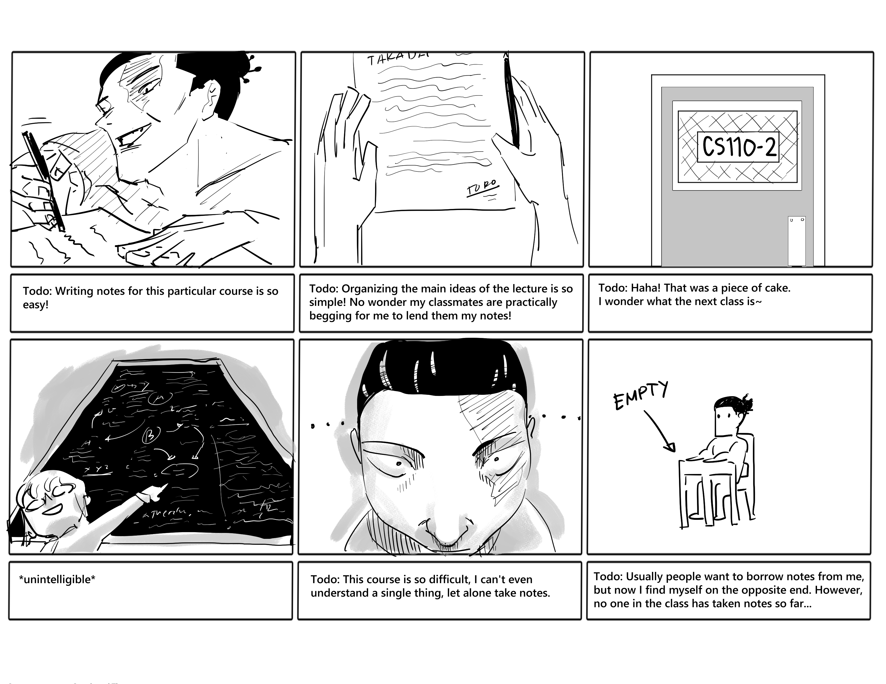

Scenario 2: Todo is particularly great at taking notes for a certain course, but has trouble pinning down what to take note of in another difficult course. Todo knows lots of people would want to borrow his notes, but he can't find anyone to borrow notes from

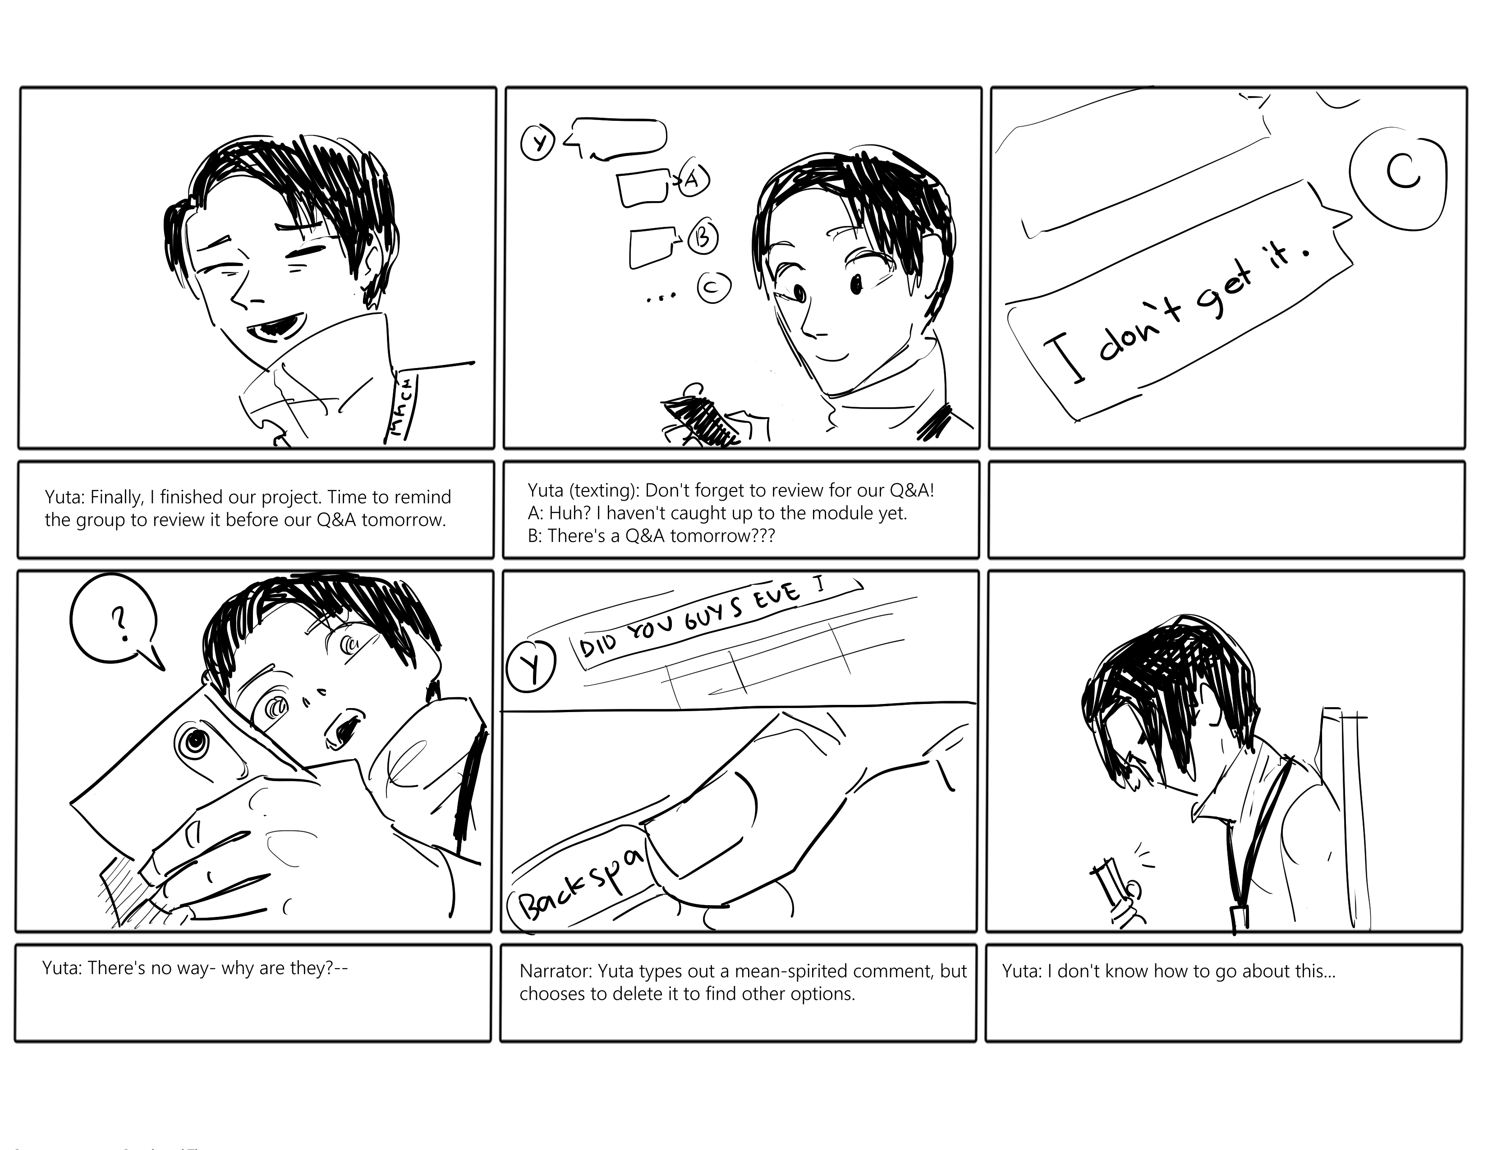

Scenario 3: Yuta is an MMCM student who is already exceptional at studying ahead, however, his group is not as good and needs to prepare for the Q&A of a presentation. Yuta needs them to review but doesn't know how to go about it

**Requirements changes**

Originally the system was proposed to also be able to link students to tutors, but that became too problematic to implement as the researchers couldn’t verify the reliability of anyone registering as a tutor, or how to properly facilitate the communication between tutor and student.